to Delivering Feedback

of 9
Submitting Video for Coaching Certification

When a candidate for coaching certification submits videos to demonstrate mastery of skills on one or more certification checklists, the candidate utilizes the following verification form in order to identify where the evidence of each skill appears in the video(s). An evaluator will review all the materials submitted (including video clips and the verification form) to determine if, and which level of, certification has been accomplished.

All videos should be submitted with the following conditions met (using Google Drive or Dropbox):
- Submit links or files to a single folder containing video of the live coaching feedback session delivered by the coach attempting certification.
- For Ruby level certification: Submit one continuous, unedited video of the coaching feedback session.
- For Emerald level certifications: Submit up to 3 continuous, unedited videos that demonstrate the emerald level certification skills.
- For Sapphire level certifications: Submit up to 4 continuous, unedited videos that demonstrate the sapphire level certification skills.
- Each video file should be titled with:
  - Your name
  - A name that describes the specific Certification level you are seeking and a video number. Example: Ima Sample Emerald Coaching Certification 3
- The verification form should also be in this folder.
- Make sure the folder’s sharing permissions is set to be “visible to anyone with the link” so that all files within the folder can be accessed (this step is essential to prevent delaying feedback).

Supervisor Approval

Each certification attempt is invoiced to resident coach’s school. Prior to submitting the video and verification form, confirm that your supervisor has approved the attempt and is expecting an invoice.

Supervisor name:
Date approved:
OR: I’m paying myself—send the invoice to the following email:

Reflection

Respond to the following prompts to give the evaluator relevant background information before completing the verification form:

1. Is there anything you want the evaluator to be aware of?
2. Things you are proud of:
3. What surprises, discoveries, or confirmations did you make while watching?

Using the Verification Form

The following form is organized to mirror the certification checklist used by an evaluator with additional space for the coach attempting certification to show where in the video(s) each element is demonstrated. This provides an opportunity to self-assess presentation skills and faster response time from the evaluator.

How to use the verification form:
- Read the whole checklist before beginning. This will give you an idea of what to watch for.
- Print out the form or fill it in on screen. All areas shaded yellow should be filled in; the other text should not be changed. If you are going to watch the video on the same screen you fill out the checklist, arrange the windows so you can see both at the same time like this:
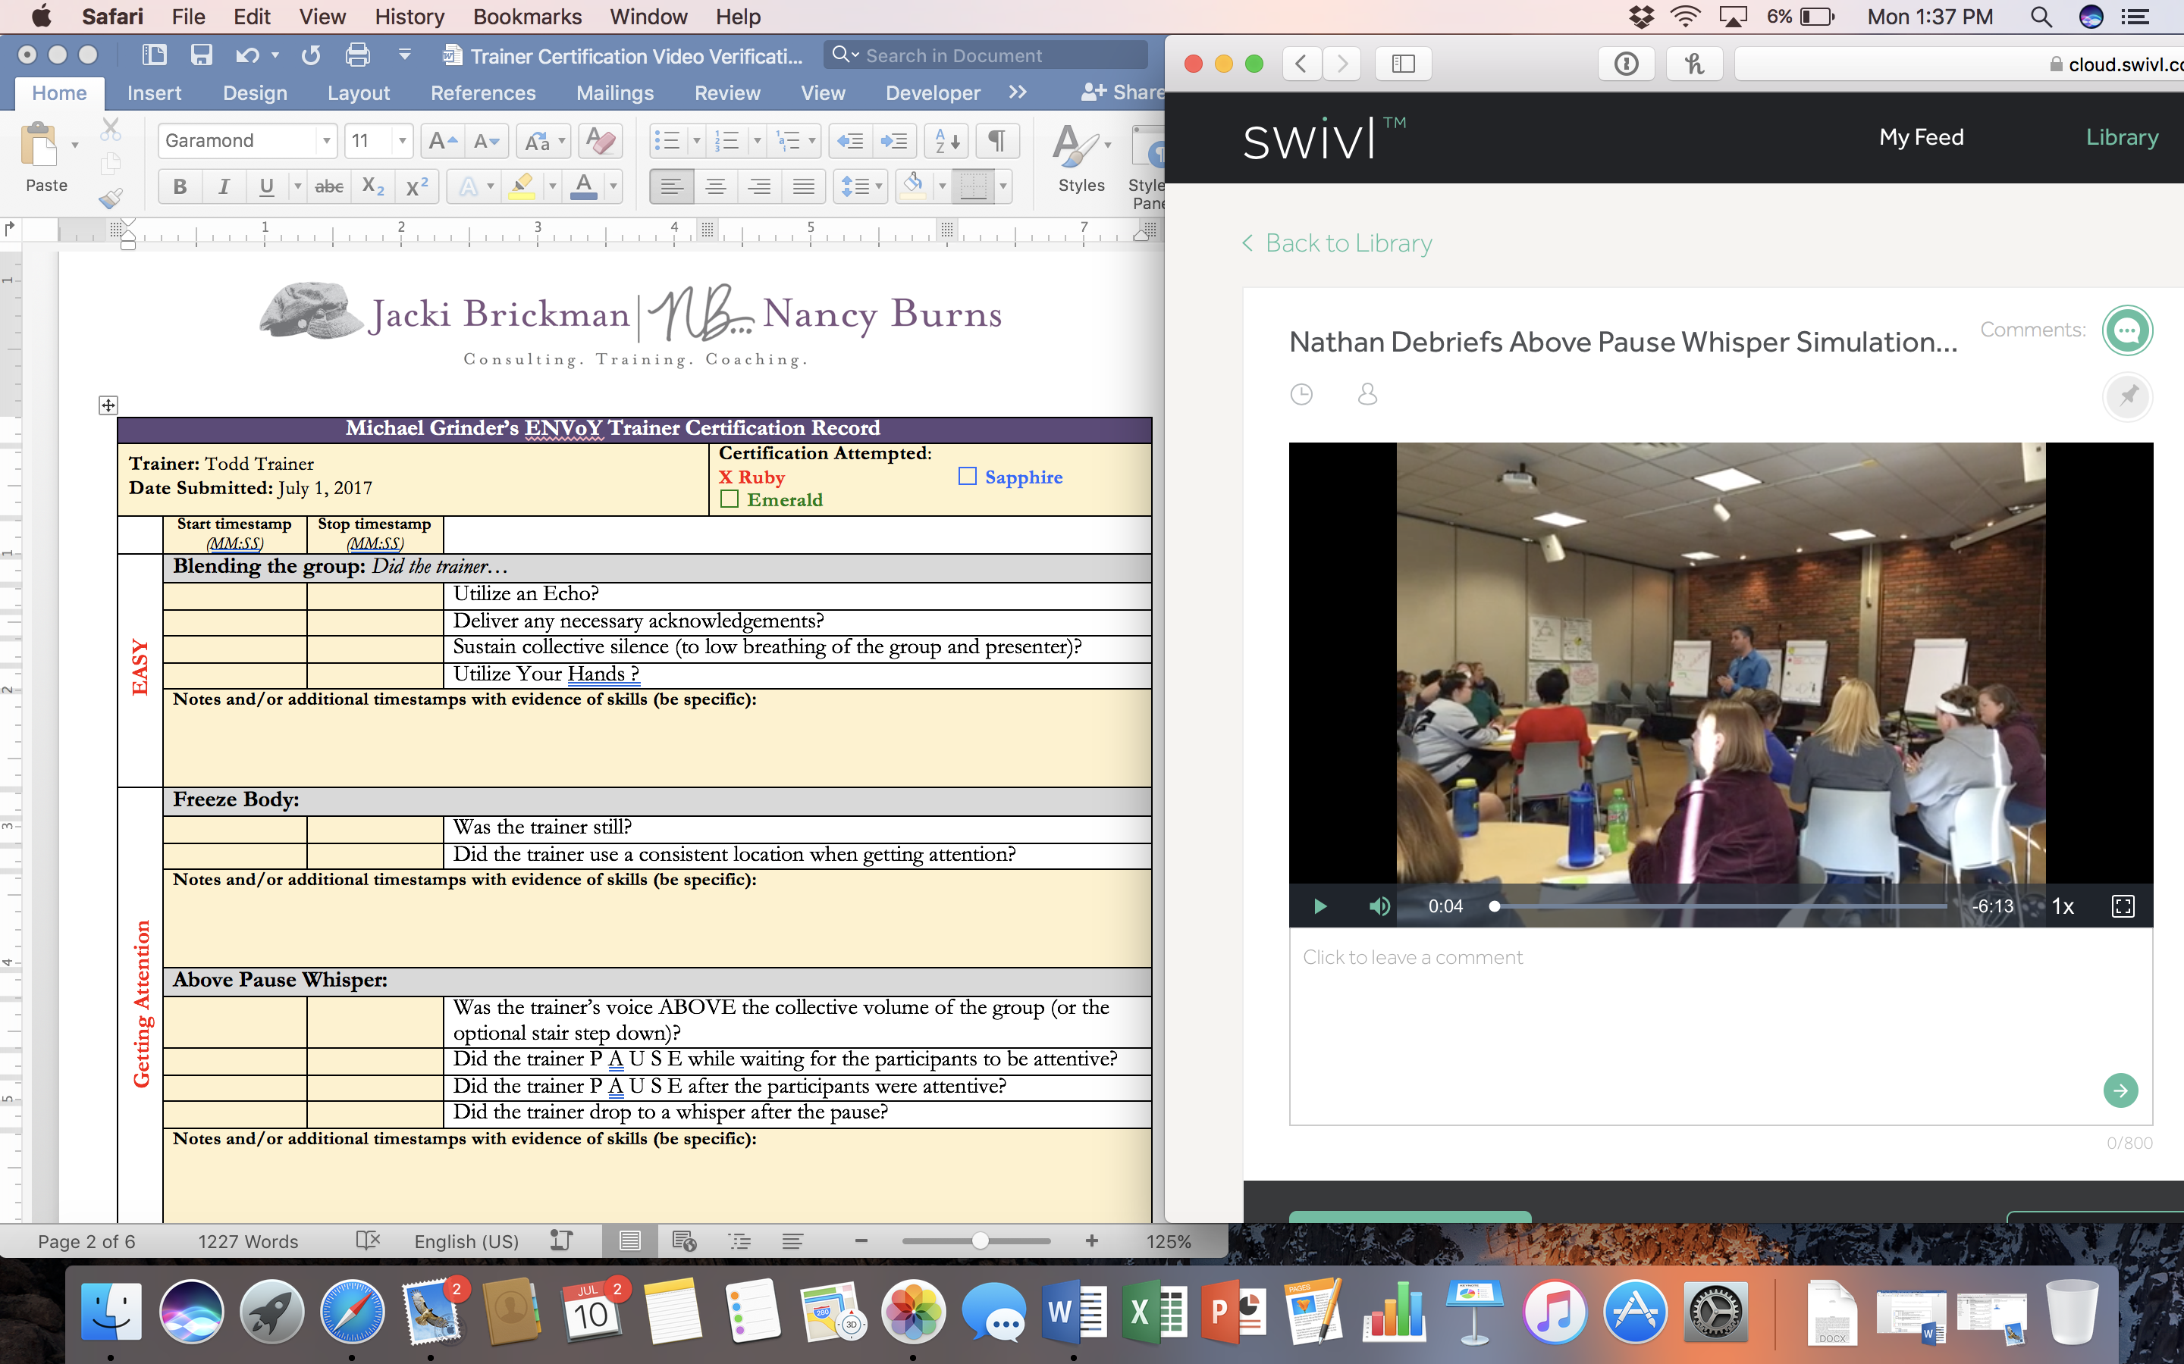
- When you see a skill demonstrated on video, fill in the time stamps for that part of the checklist. Provide additional time stamps for a given skill (if applicable) by moving down one line within the box. For components that have multiple examples to showcase, choose a few to highlight. Example:
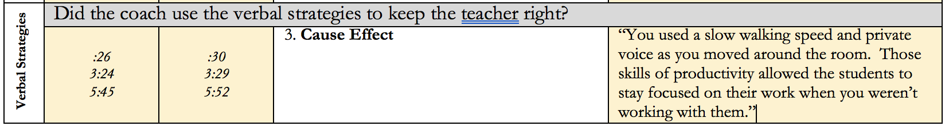
- Use the far right column to provide evidence/description for the corresponding skill.
- Continue until you have identified all the items on the checklist or you have finished the video.
- Add notes to the notes section under each skill if needed.
- Submit all items using the directions above.

to Delivering Feedback

Ruby Coach Certification Record
Internal Coach:
Date Submitted:
Link to folder containing videos:
Prerequisites (Enter dates of completion):
 |  |  | Graduate of Resident Coaches Lab Week
 |  |  | Whole Group Certified
 | Start Times  (MM:SS) | Stop Times  (MM:SS) | Checklist component | Evidence/Description
Opening | Position
 |  |  | Did the coach sit with their writing hand closest to the teacher?
 |  |  | Did the coach position themselves side by side or at 90 degrees with the teacher?
 | Commitment Statement
 |  |  | Did the coach deliver the visual commitment statement?
 |  |  | Did the coach pause between each belief item?
 |  |  | IF the teacher’s breathing increased, did the coach recover?
Core Strategies |  |  | Did the teacher own the papers?
 |  |  | Did the coach go visual with the information?
 |  |  | Did the coach utilize various points of focus (& hand-eye coordination) to support teacher understanding? 1pt. 2pt. 3pt. 4pt.
 |  |  | Did the coach keep the focus on the teacher by avoiding the violations (memory lane, ego I, statements in disguise, and evaluative statements)?
 |  |  | Did the coach use specific descriptions and avoid interpretations? (Be Specific)
 |  |  | Did the coach incorporate the swing when moving from 3rd point to 2 point communication?
 |  |  | Did the coach have consistent and purposeful pausing?
 |  |  | IF the teacher’s breathing increased, did the coach recover?
 |  |  | Did the coach maintain low breathing or IF the coach’s breathing increased did they recover with the break & breathe?
 |  |  | Was the coach aware of teacher overload level and (Tuck It) use that information to determine what feedback was shared?
Verbal Strategies | Did the coach use the verbal strategies to keep the teacher right?
 |  |  | 3. Cause Effect
 |  |  | 4. Dovetailing with Values or 5. Menu of Choices
 |  |  | 6. Contextual/Situational
 |  |  | 7. Comparative
 |  |  | 23. Describe 1st, Label 2nd
Closure |  |  | Did the coach end with a closure question for the teacher, “Of the compliments and suggestions from today, which is resonating with you?” or a variation of this closure?
 |  |  | Did the coach leave the feedback with the teacher?

to Delivering Feedback

Emerald Coach Certification Record
Internal Coach:
Date Submitted:
Link to folder containing videos:
Prerequisites (Enter dates of completion):
 |  |  |  | Ruby Coach Certification
 | Video ID | Start Time  (MM:SS) | Stop Time  (MM:SS) | Checklist component | Evidence/Description
Opening | Position
 |  |  |  | Did the coach sit with their writing hand closest to the teacher?
 |  |  |  | Did the coach position themselves side by side or at 90 degrees with the teacher?
 | Commitment Statement
 |  |  |  | Did the coach deliver the visual commitment statement?
 |  |  |  | Did the coach pause between each belief item?
 |  |  |  | IF the teacher’s breathing increased, did the coach recover?
Pentimento | Pause, Breathe, and Join
 |  |  |  | Did the coach join the information (only moves head, lips, hand when talking)?
 | Visual & Auditory
 |  |  |  | Did the coach use the voice pattern of Credibility when looking at a 3rd point?
 |  |  |  | Did the coach use the voice pattern of Approachability when giving eye contact to the teacher?
Core Strategies |  |  |  | Did the teacher own the papers?
 |  |  |  | Did the coach go visual with the information?
Did the coach utilize various points of focus (& hand-eye coordination) to support teacher understanding?
1pt. 2pt. 3pt. 4pt.
 |  |  |  | Did the coach keep the focus on the teacher by avoiding the violations (memory lane, ego I and statements in disguise, and evaluative statements)?
 |  |  |  | Did the coach use specific descriptions and avoid interpretations? (Be Specific)
 |  |  |  | Did the coach incorporate the swing when moving from 3rd point to 2 point communication?
 |  |  |  | Did the coach have consistent and purposeful pausing?
 |  |  |  | IF the teacher’s breathing increased, did the coach recover?
 |  |  |  | Did the coach maintain low breathing or IF the coach’s breathing increased did they recover with the break & breathe?
 |  |  |  | Was the coach aware of teacher overload level and (Tuck It) use that information to determine what feedback was shared?
Verbal Strategies | Did the coach use the verbal strategies to keep the teacher right?
 |  |  |  | 2. Flip (+/ Future)
 |  |  |  | 8. The Expert
 |  |  |  | 9. Goal Orientation
 |  |  |  | 10. Sanity Confirmation
 |  |  |  | 11. Expand/Transfer
 |  |  |  | 12. Laughing!
 |  |  |  | 13. Ecology
 |  |  |  | 18. First Response
Closure |  |  |  | Did the coach end with a closure question for the teacher, “Of the compliments and suggestions from today, which is resonating with you?” or a variation of this closure?
 |  |  |  | Did the coach leave the feedback with the teacher?

to Delivering Feedback

Sapphire Coach Certification Record
Resident Coach:
Date Submitted:
Link to folder containing videos:
Prerequisites (Enter dates of completion):
 |  |  |  | Currently Emerald Coach Certified
 | Video ID | Start Time  (MM:SS) | Stop Time  (MM:SS) | Checklist component | Evidence/Description
Opening | Position & Commitment Statement
 |  |  |  | Did the coach sit with their writing hand closest to the teacher?
 |  |  |  | Did the coach position themselves side by side or at 90 degrees with the teacher?
 |  |  |  | Did the coach deliver the visual commitment statement?
 |  |  |  | Did the coach pause between each belief item?
 |  |  |  | IF the teacher’s breathing increased, did the coach recover?
Core Strategies |  |  |  | Did the teacher own the papers?
 |  |  |  | Did the coach go visual with the information?
Did the coach utilize various points of focus (& hand-eye coordination) to support teacher understanding?
1pt. 2pt. 3pt. 4pt.
 |  |  |  | Did the coach keep the focus on the teacher by avoiding the violations (memory lane, ego I, statements in disguise, and evaluative statements)?
 |  |  |  | Did the coach use specific descriptions and avoid interpretations? (Be Specific)
 |  |  |  | Did the coach incorporate the swing when moving from 3rd point to 2 point communication?
 |  |  |  | Did the coach have consistent and purposeful pausing?
 |  |  |  | IF the teacher’s breathing increased, did the coach recover?
 |  |  |  | Did the coach maintain low breathing or IF the coach’s breathing increased did they recover with the break & breathe?
 |  |  |  | Was the coach aware of teacher overload level and (Tuck It) use that information to determine what feedback was shared?
Verbal Strategies | Did the coach use the verbal strategies to keep the teacher right?
 |  |  |  | 14. Reality Check
 |  |  |  | 15. Piggyback
 |  |  |  | 16. By-Products
 |  |  |  | 17. Validating positive intentions
Pentimento | Can the coach demonstrate at least one example of each of the following skills:
 | Visual
 |  |  |  | Points of Focus- systematic use
 |  |  |  | Looks at people when stating positive items
 |  |  |  | Looks at a third point when stating negative items
 |  |  |  | Looks to outside wall when referring to people not present
 |  |  |  | Looks down when separating one location, or pieces of feedback
 | Pause, Breathe, and Join
 |  |  |  | When items are positive or neutral
 |  |  |  | When transitioning from 2pt. to 3pt. eye and hand coordinated
 | Separates
 |  |  |  | When transitioning from one concept/theme to another
 |  |  |  | IF applicable, separates the problem from the solution
 | Kinesthetic
 |  |  |  | Gesture of relationship
Closure |  |  |  | Did the coach end with a closure question for the teacher, “Of the compliments and suggestions from today, which is resonating with you?” or a variation of this closure?
 |  |  |  | Did the coach leave the feedback with the teacher?

